For this first lab you will get your hardware and verify it is working.

You will:

* Retrieve all the files needed for this lab.
* How to run WinDSK8 on your LCDK hardware platform.
* How to load a program onto the LCDK through a JTAG emulator.
* How to follow instructions very precisely.
* Find out how valuable the book chapters are when running the lab experiments.

This lab uses a floating point hardware development platform from Texas Instruments. The one you will use in class is the called the OMAP-138 LCDK. You will also use an XDS-100 V2 JTAG emulator which allows the CCS environment to download code to the LCDK and allows you to debug the program once downloaded.

The book is written for users who have to do everything themselves from the start. A few things have already been done for you so you won’t have to do them in class. If you decide to setup your own laptop then this helpful material is essential to maintaining your sanity.

The first major thing already done is that Code Composer Studio is already installed on the computers in the lab. CCS is the main development environment you use for writing and testing code for the LCDK hardware platform.

Another thing you don’t have to do is re-flash the LCDK development platform to work with WinDSK8. WinDSK8 is a program which allows you to run some rudimentary applications to demonstrate some neat digital signal processing functions. This is important for you because you can run the same function on the LCDK before you have to implement them yourself. This means you know what the correctly implemented code should sound and function like.

WinDSK8 is not on the computer yet. Once you download the zip file and expand it WinDSK8 will be available to run.

Download the “Real-time Book files 3rd Edition zip files from our website. Expand it to a folder of your choice. It will look like this:

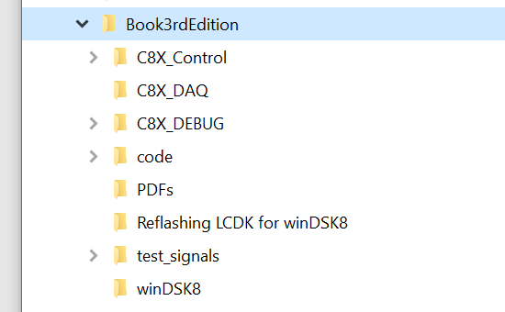

For the first part of the lab which involves WinDSK8 you will use files in the “WinDSK8” directory. For the CCS part of the lab you will use files in the “code” directory.

There is a LCDK board map in the Appendix of this document. It shows where most of the switches and connectors refered to in the document are located.

First test to see in the LCDK has been re-flashed already. Set the dip switch (SW1) to these positions:

|  |  |  |  |  |  |  |  |  |
| --- | --- | --- | --- | --- | --- | --- | --- | --- |
| Position | 1 | 2 | 3 | 4 | 5 | 6 | 7 | 8 |
| State | OFF | ON | ON | ON | X | ON | ON | ON |

Plug the 5V wall wart into the LCDK. Press the reset button on the LCDK (S1). There are 4 LED’s that should all turn on once followed by 3 sets of flashing across the LEDs getting faster each time. If this happens then the LCDK is already re-flashed and ready to work with WinDSK8. If this doesn’t happen something else is probably wrong because all of the boards have been re-flashed. Once you have verified that the LCDK is re-flashed then connect it to the computer via the USB mini connector. The mini connector should go to the LCDK USB port marked “UART USB”. The other port will not work. Connect the power to the LCDK. If it is already plugged in then press the LCDK reset button.

Go into the WinDSK8 directory in the files you downloaded before and run the WinDSK8 executable. It should open up and look like this:

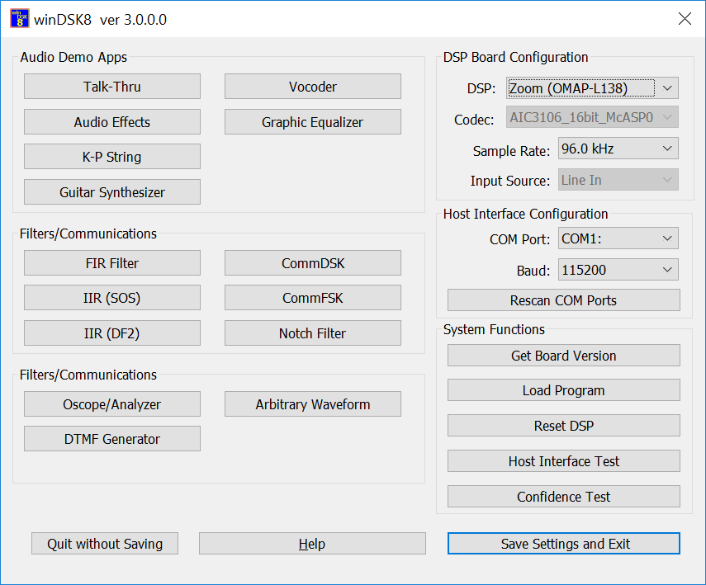

The program will NOT connect to the LCDK. The ‘DSP Board Configuration’ has to be changed.

* First the ‘DSP:’ has to be changed to LCDK (OMAP-L138).
* Then you must rescan the COM ports. Select the last one in the list. It won’t be COM1 on the lab computers.
* Next change the baud rate on the LCDK or the software so they match. Here is a table for SW1 and which switch positions versus value yields the different baud rates.

|  |  |  |
| --- | --- | --- |
| Position | 6 | 7 |
| Baud |  |  |
| 115200 | 0 | 0 |
| 230400 | 0 | 1 |
| 460800 | 1 | 0 |
| 921600 | 1 | 1 |

I suggest you use 921600 as it is the fastest and the LCDK can usually work at the fastest speed.

When all of this is done press the Get Board Version button in WinDSK8. You should get a response that shows the hardware and software versions. Once you get this running you can continue the lab. Please review the Talk-Thru chapter in the book so you know what it is you are going to do this week. It explains why this is the first thing we do with a new hardware platform that we may not be familiar with.

Now we can start doing things from the book. Start by running the WinDSK8 program if it isn’t already and the Talk-Thru app from WinDSK6. You will need to send a signal to the input through a 3.5mm RTS cable from the computer. So connect the audio input of the LCDK to the headphone output of the PC using the 3.5mm RTS to 3.5mm RTS cable. Connect headphones or an amplified speaker to the audio output of the LCDK. Once you start the talk-thru app a separate window should open that looks something like this:

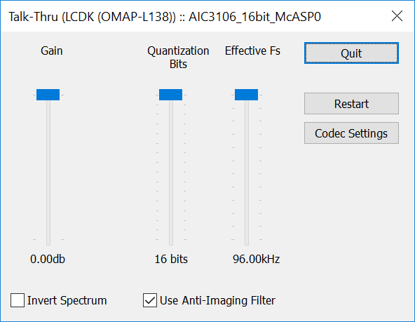

Now press the F1 key on the keyboard. This brings up help for the app. It explains what you can do with it.

Play something music, video, sounds etc. from the PC. With talk-thru running you should hear the sound coming out of the headphones. If you can’t hear anything make sure the PC is actually putting out a signal by plugging the headphones into the headphone output of the PC directly. Click on the Codec Settings button and set the sample rate, Fs, to 48KHz. Then click Done. This changes the hardware sample frequency of the LCDK. DO **NOT** CLICK Restart as this will reset the codec to run at 96KHz. Start the following you tube [Video](https://www.youtube.com/watch?v=H-iCZElJ8m0%20%20) . Don’t worry if you can’t hear anything at low frequencies. Most earbuds can’t output any sound at these frequencies. If you can hear this sound then change the Effective Fs to 4KHz. Listen to the frequency sweep again and notice the unusual thing that happens. Explain the difference in sound from the 48KHz version in your own words.

Appendix:

